Lab Session 09

EXERCISE:-

1. Design a TEMPERATURE CONVERTER from Celsius to Fahrenheit and Fahrenheit to Celsius. Present the Converter with appropriate design. Formulas for conversion are as follows:

[°C] = ([°F] − 32) · 5/9

[°F] = [°C] · 9/5 + 32

Also report the weather conditions as HOT if the temperature exceeds 35°C, WARM if the temperature is between 20°C to 35°C and COLD if the entered temperature is below 20°C.

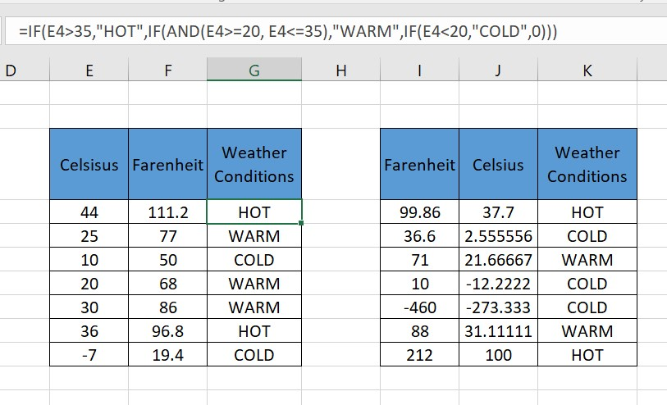

1. Create a magic square puzzle as per given example below, the sum of all the numbers in a row must be equal, simultaneously the sum of all the numbers in a column must be equal, and the sum of diagonal numbers should also be equal:

• Take the input from the user in all the squares. For a user all the squares will be blank initially and the box given below will contain the text “KEEP TRYING” unless the user enters all correct entries. If user solves the puzzle correctly then a message “WELL DONE” appears below. Format your work accordingly.

